Use Case Specification

DMT/RM01/TMP

|  |  |
| --- | --- |
| Project Code | PRJ_HotelManagement_001 |
| Project Name | Hotel Management |

|  |  |  |
| --- | --- | --- |
| Prepared/Modified by | Role | Date of Preparation |
| Harshita Ahuja | Test Engineer | 20/10/2018 |
| Reviewed by | Role | Date of Review |
| Himanshu,Ijas,Kartik | SME |  |
| Approved by | Role | Date of Approval |
| Christy | Test Manager |  |
| Circulation List |  | Version Number of the template: |
| Version Number | 1 |  |

<<Customer>> REVIEW HISTORY

<<Customer comments on the Use case along with the signed off is tracked here>>

|  |  |  |  |  |  |  |
| --- | --- | --- | --- | --- | --- | --- |
| Version | <<Version number>> |  |  |  |  |  |
| Date | <<Date of Review>> |  |  |  |  |  |
| Reviewed by | << Reviewer Name>> |  |  |  |  |  |
| Reviewed UI Specification doc | << Whether UI Specification doc is reviewed >> |  |  |  |  |  |
| All Open Queries/issues closed | << Whether all the open queries and issues resolved>> |  |  |  |  |  |
| Agreement on Assumptions | <<Whether all the assumptions have been agreed upon by the customer>> |  |  |  |  |  |
| Sign Off | <<Signature>> |  |  |  |  |  |

Disclaimer:

The scope of the project ‘<<Project Name>>’ is restricted to the contents of this signed off use case.

**TABLE OF CONTENTS**

1. Use case Name 4
2. Actor(s) 4
3. Preconditions 4
4. Flow of events 4
   1. Basic Flow 4
5. Exception Flow
   1. Exception Flow 1 5
   2. Exception Flow 2 5
   3. Exception Flow 3 6
   4. Exception Flow 4 6
   5. Exception Flow 5 6
6. Post Conditions 7
7. Special Requirements
   1. Availability 7
   2. Business Rules 8
8. Diagrams
   1. Use Case Diagram
      1. For Successful Search 9
9. Scenarios
   1. Success Scenarios 10
   2. Failure Scenarios 10
10. Issues 10
11. UI Specifications 11
12. Assumptions 11
13. Revision History of the work product 12

Use Case Name: Hotel Management system

**Use Case ID:**HotelManagement1.0

**Brief Description:**This usecase describes about the searching of the hotel rooms details by city.

2. Actor(s)

1. Customer

2. Employee

3. Admin

3. Hotel Management System

1. Preconditions
2. The user has successfully login into the site <http://ndafile:8081/Spring_Hotel/login.html>.

4. Flow of Events

4.1 Basic Flow

Name: Sucessfully search of Hotel rooms.

1. User select city.
2. User selects Arrival date.
3. User selects Departure date.
4. User clicks on Search button.
5. The system will show the details of the rooms.

Exception Flow

Exception Flow 1: unsuccessful in searching of hotel rooms due to wrong selection in arrival date.

1. User select city.
2. User selects invalid Arrival date.
3. User selects Departure date.
4. User clicks on Search button
5. System displays the error message “Arrival date should be greater than or equal to system date”.

Exception Flow 2: unsuccessful in searching of hotel rooms due to wrong selection in departure date.

1. User select city.
2. User selects Arrival date.
3. User selects invalid Departure date.
4. User clicks on Search button
5. System displays the error message “Departure date should be greater than or equal to system date”.

Exception Flow 3: Web Server Down

1. User select city.
2. User selects Arrival date.
3. User selects invalid Departure date.
4. User clicks on Search button
5. The system displays an error message regarding web server unavailability problem

Exception Flow 4: Database Connectivity Error

1. User select city.
2. User selects Arrival date.
3. User selects invalid Departure date.
4. User clicks on Search button
5. The system displays an error message regarding database connectivity problem.

Exception Flow 5: Network Connectivity Error

1. User select city.
2. User selects Arrival date.
3. User selects invalid Departure date.
4. User clicks on Search button
5. The system displays an error message regarding network connectivity problem.

Post Conditions

| **Flow Name** | **Post Condition** |
| --- | --- |
| Successful in searching of hotel | System displays the message “Hotel updated successfully”. |
| Unsuccessful in searching of hotel rooms due to wrong selection in arrival date.. | Arrival date should be greater than or equal to system date |
| Unsuccessful in searching of hotel rooms due to wrong selection in departure date. | Departure date should be greater than or equal to system date |
| Web Server Down | The system should display an error message to the user regarding web server unavailability problem |
| Database Connectivity Error | The system should display an error message to the user regarding the database connectivity problem |
| Network Connectivity Error | The system should display an error message to the user regarding the network connectivity problem |

Special Requirements

Availability

* 1. Application is up and running 24*7.

Business Rules

| **Business Rule Name** | **Business Rule Description** | **System action (if BR fails)** |
| --- | --- | --- |
| BR01 | Selection of arrival date. | Error message will get displayed if selection is wrong”. |
| BR02 | Selection of departure date | Error message will get displayed if selection is wrong |

Diagrams

Use Case Diagram

For Successful Adding hotels

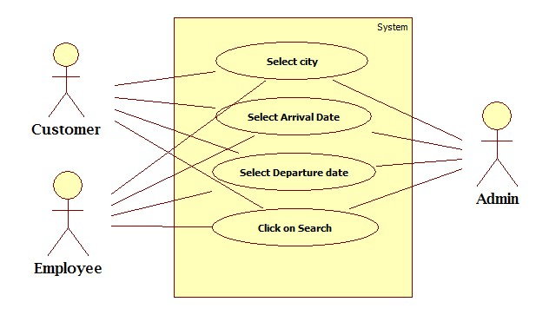

Scenarios

Success Scenarios

* Successful in searching of hotel rooms.

Failure Scenarios

* Failed submission in searching of hotel rooms due to wrong selection in Arrival date.
* Failed submission in searching of hotel rooms due to wrong selection in Arrival date.
* Failed submission in updation of hotel due to web server down.
* Failed submission in updation of hotel due to database connectivity.
* Failed submission in updation of hotel due to network error.

Issues

1. What is to be done if web server is down?
2. What is to be done if there is data connectivity error?
3. What is to be done if data is not getting retrievd?

UI Specifications

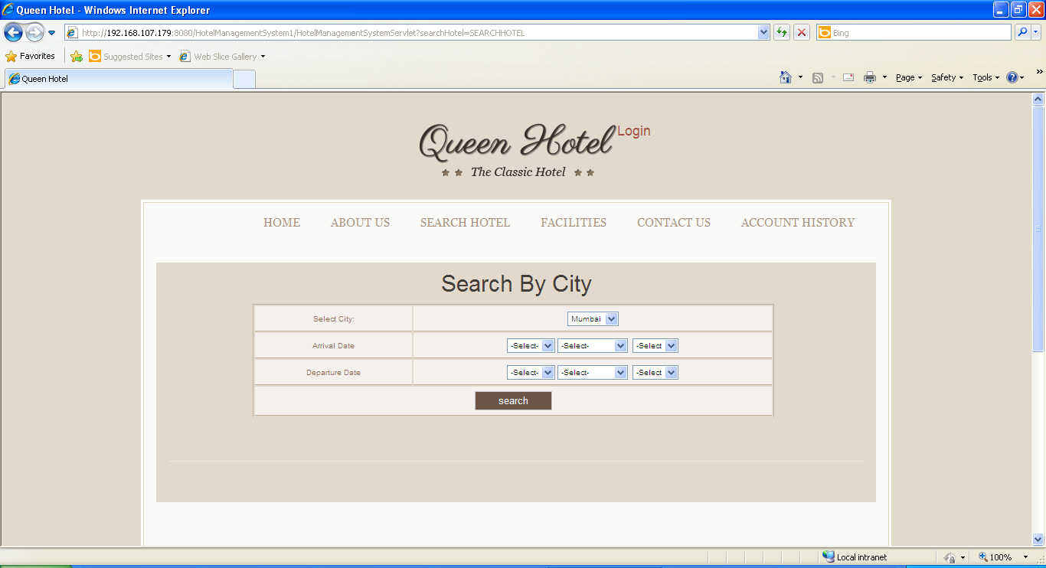

Assumptions

* 1. Only registered users can view the details of the hotel rooms.

**REVISION HISTORY OF THE WORK PRODUCT**

**<to be maintained by projects>**

|  |  |  |  |  |  |
| --- | --- | --- | --- | --- | --- |
| # | Date | Version # | Section Changed | Details of changes made | Approved By |
| 1 |  |  |  |  |  |
| 2 |  |  |  |  |  |